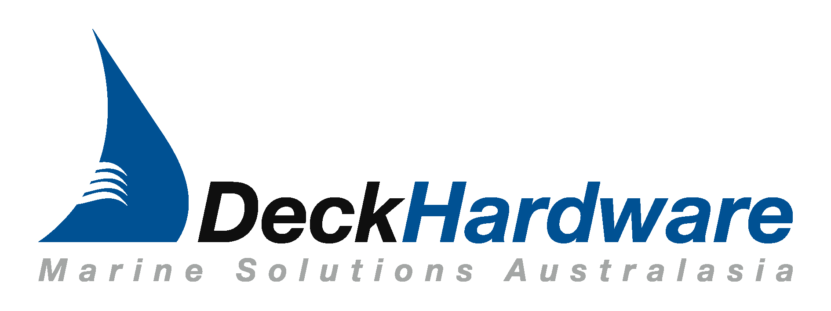


HATCH QUOTE REQUEST

Please supply the below information so we can arrange a quote for you.

DATE: ____________________________

NAME: _________________________________________________

ADDRESS: ________________________________________________

__________________________________________________________

PHONE #: _________________________________________________

FAX #: ____________________________________________________

EMAIL: ___________________________________________________

Please Circle your requirements

TYPE: Deck Hatch Low Profile Deck Hatch

Fricative Hinge Hatch Fricative Hinge Flush Hatch

STYLE: LDHS LDHR LDH LDH-N

HANDLES: Inside In/Outside Double Opening

Inside Handle for Anti Theft Locking

HINGE: Standard Fricative

CUT OUT SIZE: _____________________________________________

SPIGOT SIZE: ____________________ Angled Straight

STAY: Yes No If Yes: Pin Style Gas Style

POWDER COATING: Yes No

MATERIAL: Acrylic Tempered Glass
Please note Glass not available for Deck Hatch orders

COLOUR: Acrylic: Tanned (standard) Clear Tint Green

Glass: Clear (standard) Tanned Tint Blue Tint Green

THICKNESS: _______________________ QUANTITY:_______________

OTHER:_______________________________________________________

_____________________________________________________________

Hatches should be fitted to a flat surface with a maximum tolerance of +/- 2mm.

Fricative Hinge Flush Hatch
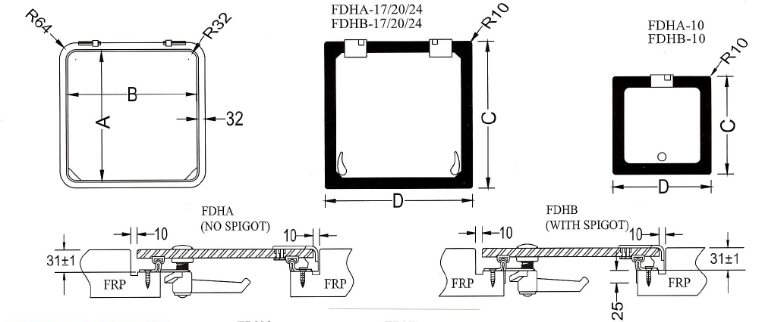

Email: phil@deckhardware.com.au

